Hash Tables

In an ideal situation, the hash table data structure will be O(1) for search, insert and delete operations

**Concept**

* Problem: how do we design a data structure to store n records of key-value pairs, ex. Name, score for efficient search by key
* Example:
  + Use array, the search time is O(n) in worst case
  + Use AVL tree, the search time is O(log n) in worst case
* What if the keys are of integer values from 0 to n-1? Yes, we can use an array of n elements to store the values, find the value of key I at position I of the array. That has O(1) time for search

**Hash Table example**

Input: given data records:

Myrie, 76.7

Ali, 88.0

Peter, 82.5

Smith, 60

Problem: Design a hast table to store the record data such that search by name can be done in constant time.

1. Define structure data type RECORD

Typedef struct{

Char name[20];

Float score;

}RECORD;

1. Create an array of RECORD type of length bigger than the record number

RECORD ht[7] = {0};

1. Use the name filed as key and define a hash function

Int h(char *str){

If(str==NULL) return -1;

Else

Return *str % 7;

}

1. Store record (name, score) at index position h(name)

For example, record (“Ali”,88.0), h(“Ali”) = 65%7=2 , is stored at ht[2] using statements:

Strcpy(ht[2].name, “Ali”);

Ht[2].score = 88.0;

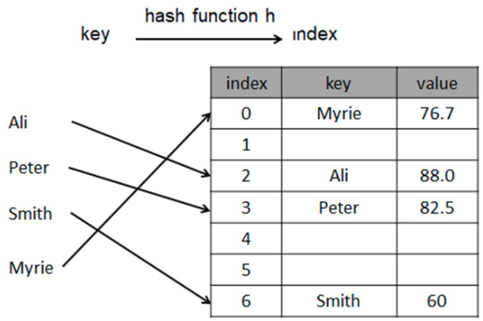

1. Search by name is to look up record at index position

Ht[hash(name)]

Int I = hash(name_str);

If(ht[h[i].name!=NULL&&strcmp(ht[i].name,name_str)==0)

Printf(“(found(%s,%f)”, ht[i].name, ht[i].score);

Else printf(“not found”);

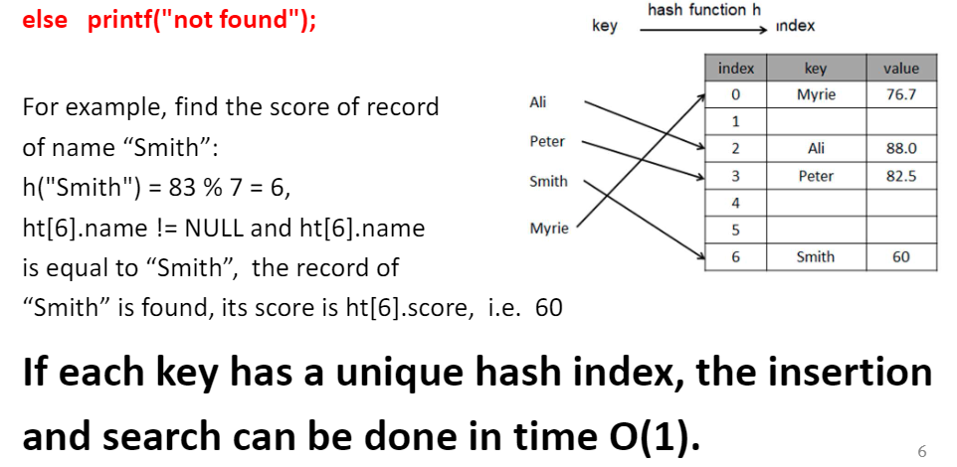

**Definition of Hash Tables**

An abstract hash table (or simply hash) is an abstract data structure with the following properties

1. It stores a collection of data values of a certain type, say hash_data_type. A part of the data type is used as key, the others (if any) are used as value, so hash_data_type can be viewed as a key-value pair (key, value).
2. An array of hash_data_type of length m, hash_data_type hash_array[m], is used to store the data records. Where m is called the size of the hash table.
3. A function h, called hash function, is used to map a key k to an integer h(k) between 0 and m-1. H(k) is called hash value of k, or index of k.
4. Insertion puts key-value pair (k,x) at hash_array[h(k)]. If the array position is taken, a resolved alternate position is used.
5. Search an element by key k (called look-up) is to check data element hash_array[h(k)]. If the key value of hash_array[h(k)] matches with k, then return hash_array[h(k)], otherwise check the data element at resolved alternative positions.
6. Delete an element by key k to remove the data element of key k at hash_array[h(k)].

* A hash table is a data structure that implements an abstract hash table with concrete hash_data_type, hash table size, hash function h, as well as insert, search (look-up), and delete operations.

**Application of hashing tables**

1. Store data records for fast search. Hash tables are used to store massive amounts of information
2. Symbol tables are used in compilers to hold variable names and their values. Ex. In C/C++ compiler, hash tables are used to keep a record of the user-defined symbol in a C++ program. Hashing facilitates the compiler to quickly look up variable names and other attributes associated with symbols.
3. Caching which saves information in memory, the other is hashing which makes looking up the file location in memory much quicker than most other methods.
4. Hash is used for database indexing. DBMS store a separate file known as indexes. When data has to be retrieved from a file, the key information is first found in the appropriate index file which references the exact record location of the data in the database file. This key information in the index file is often stored as a hashed value.

**Hash function and collision**

* Hash function, h, a mathematical function which maps a key k in set U to an integer h(k) of given modular m. h(k) is called the hash value of k by h.



Ex. U is the set of integers. Let m=10, h(k) = k mod m, k=18, h(k)=8

Ex. 2 string hash function

Int hash (char* word, int m){

Unsigned int hash = 0, i;

For(i=0, word[i] != ‘\0’;i++){

Hash+=word[i];

}

Return hash % m;

}

**Concept of collisions**

* If two keys have the same hash value by the hash function, they are said to be collided, or a collision happens on the keys by the hash function.

Ex. Given hash function m=10, h(k) = k mod . h(18) = h(28) = 8, so 18 and 28 are collided by the hash function.

* Ideal situation, namely no collisions with the given hash function and set of keys. In such a situation, the insert, search and delete operations can be done in O(1) time.

Collision is inevitable. Choose proper size m and hash function

* The size of hash table is usually chosen bigger than the number of records, i.e. 15% more, a trade-off between space and performance
* A good hash function is efficient to computer hash values for given keys. Has less number of collisions with considered key set.

**Simple hash function – Division method**

Division method uses hash function h(x) = x mod m

The division method is efficient to compute

How to choose m?

* Generally, it is best to choose m to be a prime number, m should also not be too close to exact powers of 2

Ex. M=97, calculate hash values of keys 1234 and 5462

H(1234) = 1234%97 = 70

H(5642) = 5642%97 = 16

**Drawback of the division method**

1. Consecutive keys ap to consecutive hash values. This ensure that consecutive keys do not collide
2. Consecutive array locations will be occupied. This may lead to degradation in performance.

**Collision handling**

Hash table collision problem: two keys have the same hash value corresponding to one array location, how to store the values, namely how to resolve the hash table collision?

Solution 1: when a collision happens, find an open position by probing, and store the data at the open position

How to probe?

1. Linear probing
2. Quadratic probing
3. Double hashing

Solution 2: use an alternative data structure to store all data records of the same index value.

**Linear probing (final exam topic)**

When a collision happens on insertion, find the next open position to store new data by linear probing:

If a value is already stored at location generated by h(k), then use the following hash function to find an open position

H(k,i) = [h(k) + i] mod m

Where, m is the size of the hash table, and I is the probe number and varies from 0 to m-1. Find the first i such that position h(k,i) is open.

How do we know array position is open? Values are stored in the hash table. The hash table will contain two types of values – either sentinel value (for example -1) or a data value. The presence of a sentinel value indicates that the location contains no data value at present by can be used to hold a value.

**Example**

Consider a hash table of size =10

hash function h(k) = k mod m

linear probing hash function: h(k,i) = ((k mod m) + i) mod m;

using linear probing to insert the keys 72, 27, 36, 24, 63, 81, and 92 into the table:

int T[m]; int I; for(i=0;i<m;i++) T[i]=-1;

1. Key = 72

H(72,0) = (72 mode 10 + 0) mod 10

=2 mod 10 = 2

T[2] is open, insert key 72 at T[2]

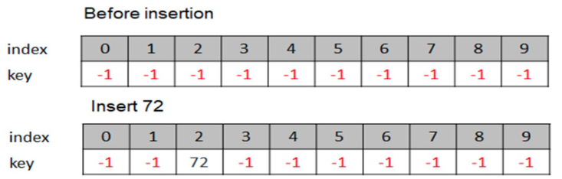

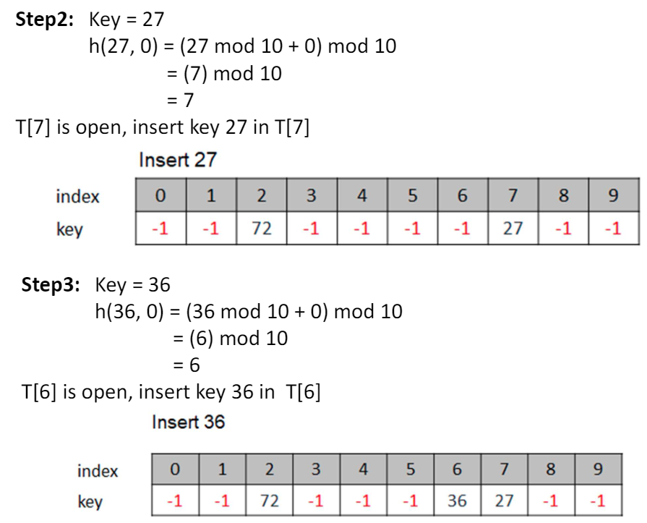

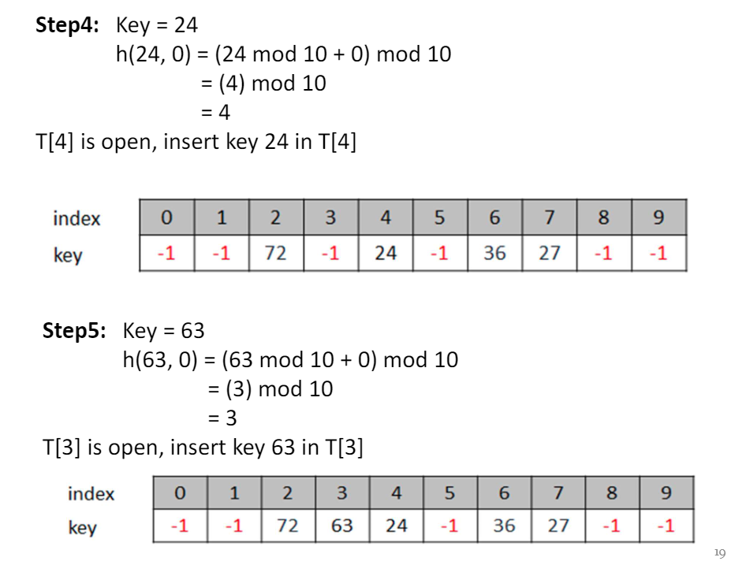

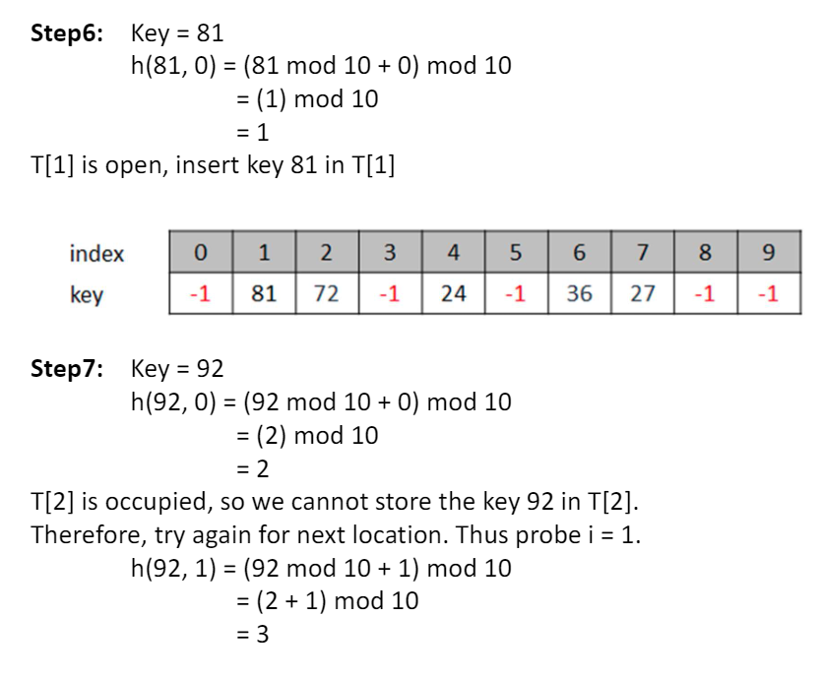

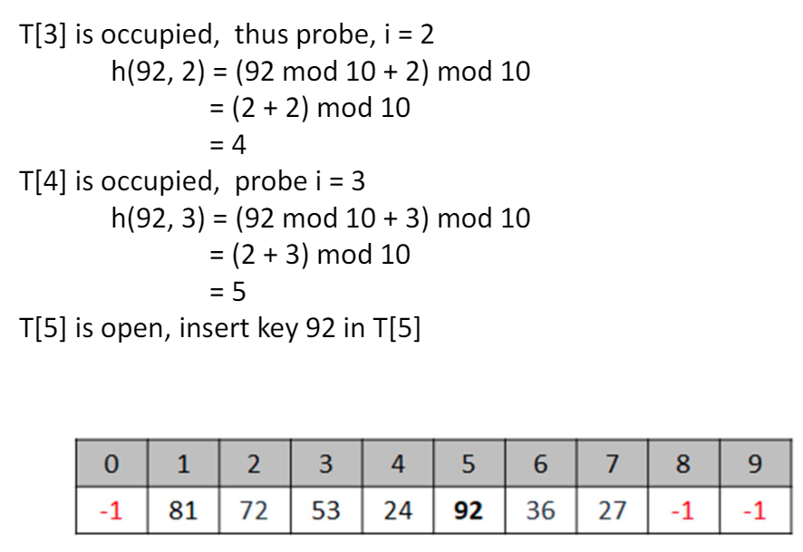

Algorithm: insert hash table by linear probing

Input: hash table ht[m], key-value pair (k,val)

1. Set i=0 and j=s = h(k,i)
2. If ht[j] has key value -1

Store (k,val) at ht[j]

Goto step 5

1. Set I = i+1, j = h(k,i)

If j==s

Goto step 4

Else

Goto step 2

1. Output -1 (hash table is full, overflow, insertion failed)
2. Output j (return the inserted position)

Time: O(m), space O(1)

**Search by linear probing**

Solution:

When searching a value in the hash table, compute the hash value of the search key, check the data at the hash value position. If a match is found, then the search operation is successful. The search time in this case is given as O(1).

Otherwise, if the key does not match, then check the next index position of linear probing until the value is found or the search function encounters a vacant location in the array, indicating that the value is not present.

Algorithm: search hash table by linear probing

Input: hash table ht[m], and key value k

1. Set i=0, j = s = h(k,i)
2. If k matches the value value of ht[j]

Goto step 4

1. Set I = i+1, j = h(k,i)

If j == s or ht[j] == -1

Goto step 5

Else

Goto step 2

1. Output ht[j];
2. Output NULL (not found)

Time O(m), space O(1)

**Pros and cons of linear probing**

* Pros
  + Linear probing finds an open location by doing a linear search in the array beginning from position h(k)
  + The algorithm provides good memory caching, through good locality of reference
* Cons
  + It results in clustering, and this a higher risk that where there has been one collision there will be more
  + The performance of linear probing is sensitive to the distribution of input values

**What do we do when a hash table is full?**

Solution: rehashing

1. Create a new hash table of bigger size ex. 2m
2. For each data record in the current hash table, insert it to the new hash table
3. Clean the old hash table

**Collision resolution by chaining**

* Resolving collision by chaining is to use an alternative data structure (such as linked list, BST< AVL) to store all data records of the same hash value. So insert, search, delete operations are just to do the operation on the corresponding data structure of the hash value.
* Specifically, the hash table array ht[m] stores pointers of linked data structures. Ht[i] holds the pointer to the data structure storing all key-value data records of the same hash index value i.

**Linked hash tables**

* If a linked data structure is used to store all key-value record of the same hash index, we call it a linked hash table. It is a hybrid data structure which contains an array and m linked data structures.
* If a linked list data structure is used to store data records of the same hash index, it is called chained hash table.
* The insert, search, and delete operations on linked hash table mainly have two steps
  + Step 1. Computer the hash index value of the given key
  + Do insert, search, or delete operation on the associated linked data structure at the hash index position.

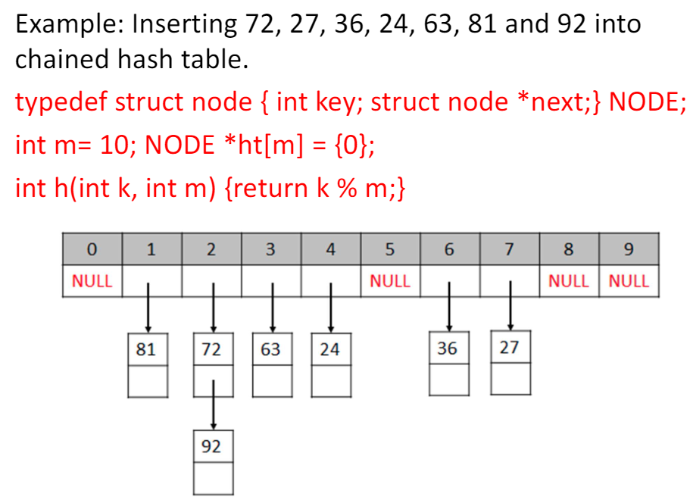

**Pros and cons of chained hash tables**

* Pros
  + It remains effective even when the number of records to be stored is bigger than hash table
  + The performance does not degrade when the table is more than half full, efficient to handle collisions
* Cons:
  + There is space overhead for using linked data structure
  + Traversing a linked list has poor cache performance, making the processor cache ineffective
  + With the increase in number of records to be stored, the performance of chained hash table does not degrade gracefully (linearly)), O(n/m) on average.

**Java HashMap**

* Java’s hashtable, hashmap, hashset are internally based on linked hash table data structures; Array of references (called buckets) is used, each bucket holds the key-value pairs of the same hash value of keys, and is implemented by linked list.

Size – number of data elements

Capacity – the maximum length of array

Load factor (LF) = size / capacity

When LF >=0.75, i.e. 3 quarters of its capacity then

* Double the array capacity by creating a new array of the new capacity, followed by rehashing. Rehashing is to insert each key-value pair data element of the old hash table to the new hash table. Use insert at the beginning of each linked list of bucket.

**Multiplication Method**

1. Choose a constant A such that 0 < A < 1
2. Multiply the key k by A
3. Extract the fractional part of kA
4. Multiple the result of step 3 by m and take the floor

Hence, the hash function can be given as, h(k) = floor(m(kA mod1))

Where, kA mod 1 gives the fractional part of kA and m is the total number of indices in the hash table

The greatest advantage of the multiplication method is that it works practically with any value of A. Better to choose A = (sqrt(5)-1)/2 = 0.6180339887

Example: Given a hash table of size 1000, map the key 12345 to an appropriate location in the hash table.

We will use A = 0.618033, m=1000 and k =12345

H(12345) = floor(1000(12345 x 0.618033 mod 1))

= floor(1000 (7629.617 mod 1))

= floor (1000(0.617385))

=617.385

=617

**Mid square Method**

1. Square the value of the key. That is, find k2
2. Extract the middle r bits of the result obtained in step 1.

Example: Calculate the hash value for keys 1234 and 5642 using the mid square method. M=100. Hash value has two digits, so r = 2.

When k=1234, k2 = 152**27**56, h(k) = 27

When k = 5642, k2 = 3183**21**64, h(k) = 21

Observe that the 3rd and 4th digits from the right are chosen

This algorithm works well because most or all bits of the key value contribute to the result. This is because all the digits in the original key value contribute to produce the middle two digits of the squared value. Therefore, the result is not dominated by the distribution of the bottom digit or the top digit of the original key value. In the mid square method, the same r bits must be chosen from all the keys. Therefore, the hash function can be given as, h(k) = s where, s is obtained by selecting r bits from k2.

**Folding Method**

1. Divide the key value into a number of parts. That is divide k into parts k1,k2,…,kn where each part has the same number of digits except the last part which may have lesser digits than the other parts.
2. Add the individual parts. That is obtain the sum of k1 + k2 + … + kn. Hash value is produced by ignoring the last carry, if any.

The number of digits in each part of the key depends on the size of the hash table. For example, if the hash table has a size of 1000. It needs at least 3 digits.

Example: Given a hash table size m = 100. Calculate the hash value using folding method for keys 5678, 321 and 34567.

Here, since there are 100 memory locations to address, we will break the key into parts where each part (except the last) will contain 2 digits.

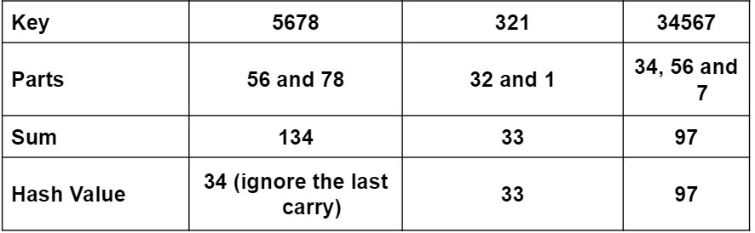

**Advanced Probing**

**Quadratic Probing**

In this technique, if a value is already stored at location generated by h(k), then the following hash function is used to resolve the collision.

H(k,i) = [h’(k)+c1*i+c2*i2] mod m

Where, m is the size of the hash table, h’(k) = k mod m and I is the probe number that varies from 0 to m-1 and c1 and c2 are constants such that c1 and c2 do not equal 0.

Quadratic probing eliminates the primary clustering phenomenon of linear probing because instead of doing a linear search, it does a quadratic search. For a given key k, first the location generated by h’(k) mod m is probed. If the location is free, the value is stored in it. Else subsequent locations probed are offset by factors that depend in a quadratic manner on the probe number i. Although quadratic probing performs better than linear probing but to maximize the utilization of the hash table, the values of c1, c1 and m needs to be constrained.

Example: Consider a hash table with size = 10. Using quadratic probing insert the keys 72, 27, 36, 24, 63, 81, 101 into the table. Take c1 = 1 and c2 = 3. H’(k) = k mod m, m=10

Initially the hash table can be given as,



We have, h(k,i) = [h’(k) + c1*I + c2*i2] mod m

1. Key = 72

H(72) = [72 mod 10 + 1x0 + 3 x 0] mod 10

= 2

T[2] is open, insert the key 72 in T[2]



